

High Level Design & Low Level Design

**Document Control :**

|  |  |  |  |  |  |  |  |  |  |  |  |  |  |  |  |  |
| --- | --- | --- | --- | --- | --- | --- | --- | --- | --- | --- | --- | --- | --- | --- | --- | --- |
|  | |  | |  | | |  | |  | |  | |  | |  | |
| Double Tree Hotel Billing | | | | | | | | | | | | | | | | |
| Guided by –  **Aliasger Mulla** | |  | |  | | |  | |  | |  | |  | |  | |
| **Date** | | **Version** | | **Author** | | **Brief Description of Changes** | | | | | | | **Approver Signature** | | | |
| 20-10-2022 | | 1.0 | | Pavithra, Divya Snehitha,  Likhitha, Neelima, Pallavi | | Booking Id, customer Id,  Checks-in, checks-out,  Room type, Bill | | | | | | |  | | | |
|  | |  | |  | |  | | | | | | |  | | | |
|  | |  | |  | |  | | | | | | |  | | | |

**Index**

1. Introduction ------------------------------------------------ 4

1.1 Intended audience ------------------------------------------------ 4

1.2 Project purpose ------------------------------------------------ 4

1.3 Key project objective ------------------------------------------------ 4

1.4 Project scope and limitation ------------------------------------------------ 4

1.5 Functional overview ------------------------------------------------ 4

1.5.1Header files ------------------------------------------------ 5

1.5.2 Functions ------------------------------------------------ 6

2. Design overview ------------------------------------------------ 6

2.1 Design objective ------------------------------------------------ 8

2.2 Design alternative ------------------------------------------------ 8

2.3 User interface paradigms ------------------------------------------------ 8

2.4 Error detection/ Exceptional Handling ------------------------------------------------ 8

2.5 Performance ------------------------------------------------ 8

2.6 Maintenance ------------------------------------------------ 8

3.. Detailed system design -----------------------------------------------10

4. Environment description ------------------------------------------------10

4.1 Time zone support ------------------------------------------------11

4.2 Language support ------------------------------------------------11

4.3 User desktop requirement ------------------------------------------------11

4.3.1Deployment consideration ----------------------------------------------- 11

4.3.2 Integration requirements ------------------------------------------------11 4.3.3Network -------------------------------------------------11

4.4 Configuration ------------------------------------------------11 4.4.1 Operating system ------------------------------------------------11

**1.Introduction: -**

* 1. **Intended Audience: -**

The document is intended to be read by, Client.

* 1. **Project Purpose: -**

The purpose of hotel billing record system is used to capture the bill record of customers to come up with total amount to be paid by the customer. The information is saved to a database to enable management or users to retrieve saved billing records. The service rendered by hotel industry is associated with charges

* 1. **Key Project Objectives: -**

1. Allow Admin for registrations

2. Allow users to login

3. Validates personal data (first name, last name, permanent address)

4. Allow admin to add, delete and update bookings using Booking Id

5.Allow the customer to choose rooms

6.Bills should be displayed at the time of check-out of customer

**1.4 Project scope and limitation: -**

This billing system focus on the development of an information system that will automate manual transaction in hotel

1.It will generate receipt on every transaction inputted to the system.

2.The software will display view of calculations of every transaction.

3.For security and privacy of the management, the Billing System comply two log-in users with different access level.

4.The system will store and recognize customer reservations

**1.5 Functional Overview: -**

1.5.1 Following header files are included in the program:

1. #include <stdio.h>
2. #include <ctype.h>
3. #include <stdlib.h>
4. #include <time.h>
5. #include <terminos.h>

1.5.2. Following functions are included in the program:

**a. Application process:** Insert the data to identify and manage the customer booking check-ins, check-outs, and bill book for double tree

b. Customer ID: under the booking Id, Admin can add/update/delete customer using customer Id. They follow the below information that customer should follow

* Customer Id(auto-generated)
* First Name
* Last Name
* Permanent Address

c. Booking ID: under the booking Id, once Admin can add/update/delete booking using booking Id. Booking conformation should be sent to the specified details

* Booking Id (auto generated)
* Customer ID
* Booking date (in “dd/mm/yy” format)
* Stay start date (in “dd/mm/yy” format)
* Stay end date (in “dd/mm/yy” format)
* NoOfPersons (in “dd/mm/yy” format)

d. Check-ins and check-outs: Application should maintain check-ins and check- outs database in text files and admin can add/update /delete entries of the check-ins and check-outs using booking ID

e. Information about rooms: Information about the rooms in a resort is available in rooms .txt. They follow the below information

* Room No
* Floor No
* Room Type(standard/deluxe/cottage)
* Description
* AC/non-AC
* NoOfExtraBeds

f.Bills should be displayed at the time of check-out of customer:

once bill is paid it can be updated or delete. Bill should be displayed at the time of check-out of customer Bill details can be displayed as follows

* BillId: ______________
* Customer Name: ____________
* No. of days of stay: ____________
* Total Bill: ___________________

g. Total Bills: Calculate and display accommodation charges and other utilities calculations of the bill is: total Bill= (noOfDaysOfStay*base room fare) + NoOfDaysOfStay *(FOOD_CHARGE) + (EXTRA_PERSON_CHARGE* (noOfExtraPerson)

totalBill = totalBill + TAX * totalBill

h. Room Type: Under type We can consider the different types of rooms based on prices as follows below

* Room Type -Base Room (in Rs.)
* Standard -2500
* Deluxe-3500
* Cottage-5500

i. Validations: under validations we must be follow the instructions such as

1**)** 0 - 2 persons are allowed extra per room. If the extra person is more than 2, display an appropriate message on the console.

2) Valid room types are specified in NV03. If the user entered room is not of these types, display an error message in the console.

3) Validate for number of valid days and display appropriate message in the console.

4) All date validations.

j. Proper Validations s: Ensure proper validation across all entries

Department Store comprises of the following modules:

|  |  |
| --- | --- |
| Name of the Module | Admin |
| Handled by | Divya Snehitha |
| Description | Customers, Bookings, Check-ins, Check-outs,  Bill book |

|  |  |
| --- | --- |
| Name of the Module | Customer |
| Handled by | Divya Snehitha |
| Description | First name, Last name, Permanent address  Admin can add, delete, update customer using CustomerId |

|  |  |
| --- | --- |
| Name of the Module | Booking |
| Handled by | Pavithra |
| Description | Booking Id, Customer Id, Booking date, Stay start Date, Stay end date, NoOfPersons  Admin can add, delete, update customer using BookingId |

|  |  |
| --- | --- |
| Name of the Module | Rooms information |
| Handled by | Pavithra |
| Description | Room type, Room number, Noofextrabeds  Floor no, A/C non AC  Hotel management can manage the budgets and handling customer complaints and queries and also promoting the marketing the business. |

|  |  |
| --- | --- |
| Name of the Module | Bills |
| Handled by | Pallavi |
| Description | BillId, Customer Name, No. of days stay, TotalBill    Bills should be display at the time of customer  Check-out. |

|  |  |
| --- | --- |
| Name of the Module | Total Bill |
| Handled by | Pallavi |
| Description | Total Bill= (noOfDaysOfStay*base room fare) + NoOfDaysOfStay *(FOOD_CHARGE) + (EXTRA_PERSON_CHARGE* (noOfExtraPerson)  totalBill = totalBill + TAX * totalBill |

|  |  |
| --- | --- |
| Name of the Module | Room Type |
| Handled by | Likhitha |
| Description | Standard  Deluxe  Cottage |

|  |  |
| --- | --- |
| Name of the Module | validations |
| Handled by | Neelima |
| Description | proper validation across all entries. |

## 

## Design Objectives: -

* Customer Edit
* Room Available
* Room booking
* Generate Bill
* Check in-out
  1. **Design Alternative****: -**

We have used admin to add, update, delete the customer using customer Id. Customer can update their personal details like name, address Etc.

### 2.3 User Interface Paradigms: -

The Double tree hotel billing application gives access to the admin to login with a username and password. The details of the customer stored in a file.

Admin is given an interface to register a customer, interface for login and exit as well. After login in, customer gets the interface to choose rooms information.

### Error Detection / Exceptional Handling: -

The admin has to login with valid credentials. otherwise, they will get invalid username or password. After logging in, the customer can start to choose the rooms.

### Performance: -

The system will work on the admin. The performance depends on the hardware component of the user’s system.

### Maintenance: -

Hotel maintenance encompasses all maintenance actions that are taken in order to maintain and repair all systems, components, and equipment that are a part of a hotel property. The exact scope of maintenance work greatly varies from one hotel to another, based on the size of the hotel and the range of services it offers.

Hotel maintenance can be looked at as one type of [building maintenance](https://limblecmms.com/blog/building-maintenance/) that places extra focus on issues that concern hotel guests. In other words, hotel maintenance puts more emphasis on things like plumbing, HVAC, lighting, and visual representation of the whole establishment.

After all, having all building systems running smoothly puts the hotel in the fast lane that ends in a positive word of mouth.

**3.DETAILED SYSTEM DESIGN**

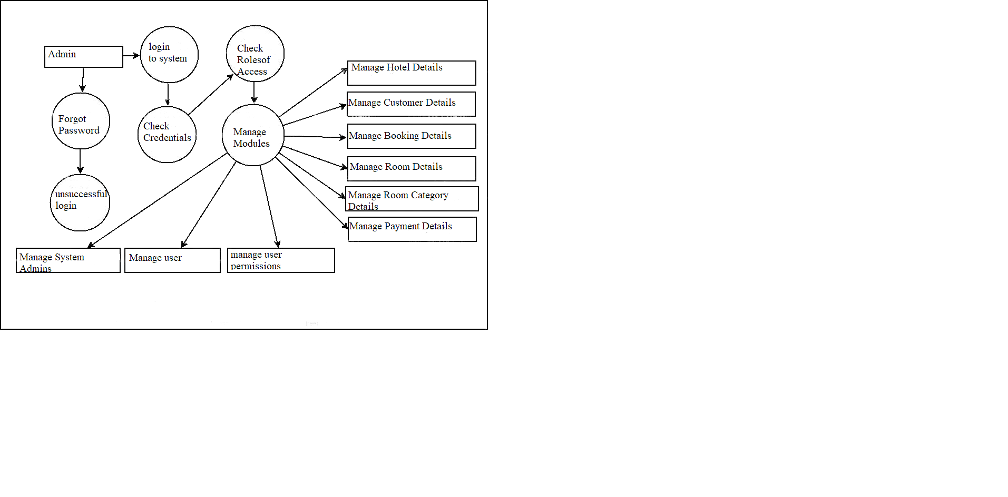

**4. Environment Description: -**

**4.1 Time Zone Support: -** IST

**4.2 Language Support: -** English

**4.3 User Desktop Requirements: -**

a. 64-bit processor, 1 GHz or faster

b. At least 2 GB free hard drive space

c. At least 1 GB RAM

4.3.1. Deployment Considerations: -

System is easy to deploy

4.3.2. Integration Requirements: -

a. Language: - C

b. Tools: - Valgrind, Makefile, Ctags

c. Complier: - gcc

d. Linux Environment

4.4.3. Network: - End to End

**4.4 Configuration: -**

4.4.1. Operating System: - Linux environment